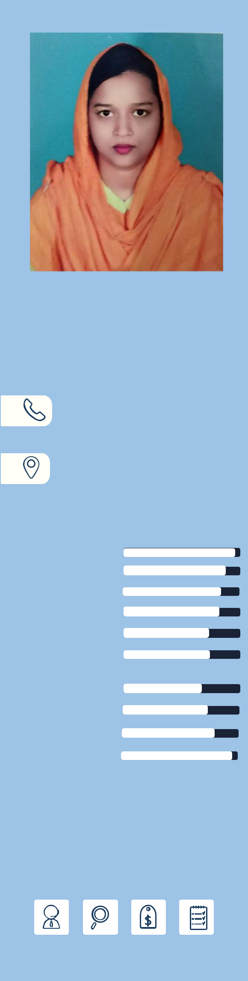
Zannatun Nayem

Career Objectives

To pursue my goal by learning new things, explore new ideas and utilizing every possible way to develop my skillsets with absolute dedication, sincerity, honesty and hard work.


Education

CONTACT
 zannatsumaiya.bauet36@gmail.com

+8801784790429

+8801701080752

Talaimary, Rajshahi-6204, Bangladesh

2020-Present

2015-2019

2011-2013

2009-2011

M.Sc. in Computer Science and Engineering, Rajshahi University of Engineering & Technology, Bangladesh.

B.Sc. in Computer Science and Engineering, Bangladesh Army University of Engineering & Technology, Natore

CGPA: 3.91 (Out of 4.00, 1st Class 3rd Position)

H.S.C. in Science,

Puthia Islamia Mohila Degree Collage GPA: 4.80 (Out of 5.00)

S.S.C. in Science,

Jhalmolia High School

GPA: 5.00 (Out of 5.00)


COMPUTER SKILLS

C\C++

HTML\CSS

SASS

Bootstrap

PHP

Assembly

Language

Photoshop

Python

MATLAB

Microsoft

Office

HOBBIES

Experience

Working as a “Digital Marketing Executive” in “Desktop IT” in Rajshahi from 1st November 2020.


Research Skills

• | Image Processing | • | Embedded System
• | Artificial Intelligence | • | Natural Language Processing


B.Sc. Thesis

Title: A Language Model Developed for Intelligent Digital Assistant using Deep learning.

Supervisor: Dr. Mirza A.F.M. Rashidul Hasan, Head, Department of Computer Science and Engineering, Bangladesh Army University of Engineering & Technology, Natore.


Publication

Journal:

- Jaman, Khandokar Nafis, Zannatun Nayem, Bristi Rani Roy, Nayreet Islam, Faisal R. Badal, and Subrata K. Sarker, “A Text Watermarking Algorithm Developed Using Natural Language Processing”, Semantic Scholar, 2019.


Industrial Training

Taken an industrial training course of 30 days duration at “Raj IT” at Rajshahi.


Soft Skill

- Organized several cultural and departmental official programs.

- Involved in outdoor games such as Badminton, Table Tanis and in Voluntary work with university students.

- Chief Executive Coordinator of C++ at BAUET programming club

- Can work in teams.


Projects

• Exam Management System in C

• Store Management System in PHP


References

Dr. Mirza A.F.M Rashidul Hasan | Md. Faisal Rahman Badal
Head, | Lecturer,
Department of Computer Science & Engineering, | Department of Mechatronics Engineering
Bangladesh Army University of Engineering & | Rajshahi University of Engineering & Technology
Technology | Contact: +8801763130652
Contact: +8801715249842 | Email: faisalrahman@mte.ruet.ac.bd
Email: mirza_iu@yahoo.com
Declaration


I do, hereby, declare that all of the above information is true and correct to the best of my knowledge.

Signature

Zannatun Nayem

